Mother dairy
Introduction
Mother Dairy is a major dairy brand offering a range of products to customers through different sales channels and locations. Understanding sales performance is important for a company because it helps managers make informed decisions about products, pricing, inventory, distribution, and customer demand.
This project analyzes the supplied dairy dataset using sales and operational information. It includes product names and brands, quantities sold, selling prices, approximate revenue, customer locations, sales channels, stock levels, and product shelf-life details. It also contains information about farms, such as farm size, land area, and number of cows.
The analysis aims to turn these records into useful business insights. It examines which products and brands contribute most to revenue, how sales differ by channel and location, and whether the records highlight inventory or expiration concerns. These findings can help guide further investigation and support better planning.
Data note: The file provided is a dairy dataset, which fits the Mother Dairy name. The analysis describes the contents of that file; it does not verify that the records are official Mother Dairy company data.
Objectives of the Sales Analysis
The main objective of this project is to analyze sales performance and related business information in the supplied dataset. The specific objectives are:
- Analyze revenue by product
Calculate and compare approximate total revenue for each product. This helps identify products that make the largest contribution to recorded sales.
- Compare revenue by brand
Summarize revenue for each brand in the dataset to identify which brands account for the highest recorded sales.
- Review monthly and yearly revenue trends
Group revenue by month and year to understand how sales change over time. Trends can help identify stronger or weaker periods for follow-up analysis.
- Compare sales channels
Examine revenue and quantity sold through Retail, Wholesale, and Online channels. This can show which channels account for the most recorded sales.
- Identify high-volume customer locations
Compare the quantity sold to customers in different locations to find where recorded purchase volumes are highest.
- Compare listed and selling prices
Review the listed price per unit alongside the actual price per unit sold. This can help identify where selling prices differ from listed prices.
- Review product profitability
Estimate profit by product where the dataset supports a suitable cost calculation. Any profit result should clearly state how cost is defined, since the dataset does not include an explicit cost-of-goods-sold field.
- Review stock levels and replenishment needs
Identify records where quantity in stock is below the minimum stock threshold and review the reorder quantity. This can help highlight products that may require replenishment.
- Examine shelf life and expiration information
Identify records with short remaining shelf life or expiration dates that precede the recorded sales date. These records may need checking before operational decisions are made.
- Explore farm and production information
Summarize farm size, land area, number of cows, and production-related fields to describe the operational context represented in the dataset.
insights
- Total revenue generated by each product
- Give Brand with the highest total revenue
- Give Monthly revenue trend across all products
- Products below the minimum stock threshold
- Total reorder quantity required per product
- Which sales channel generates the most revenue
- Top 5 customer locations by purchase volume
- Average selling price per product
- Compare selling price with listed price
- Products with less than 10 days shelf life remaining
- Average shelf life by product category
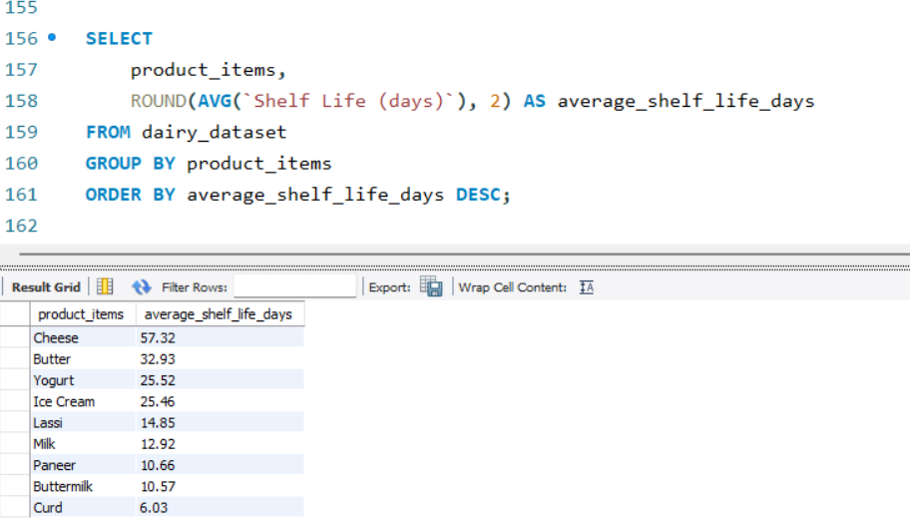

- Average number of cows per farm size category
- Location with the largest total land area
- Top 3 locations by average production quantity
- Calculate profit for each product

- Most profitable brand overall
- Yearly revenue growth
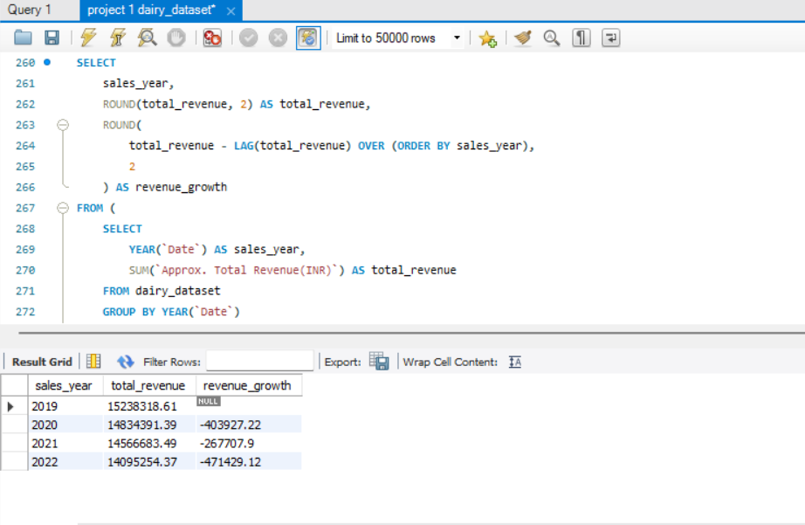
- Best-selling product each year
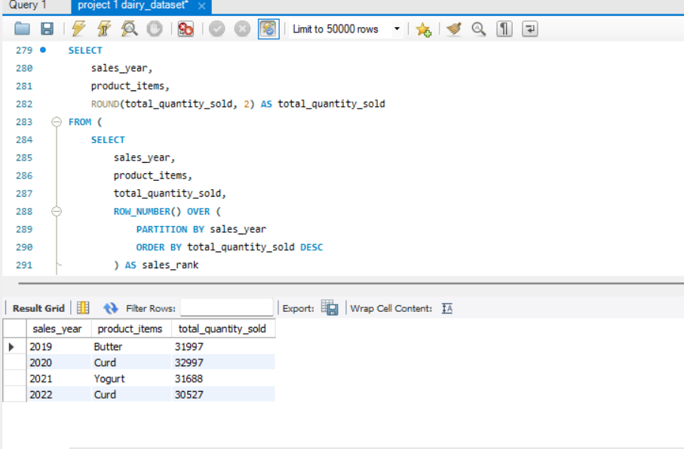
- Products that need immediate restock
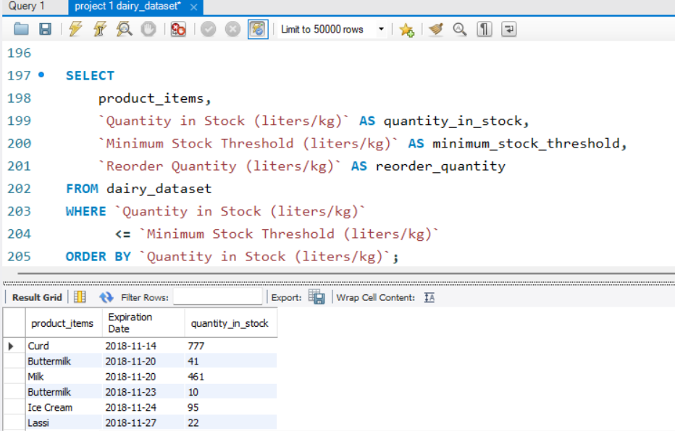
- Identify expired products still in stock
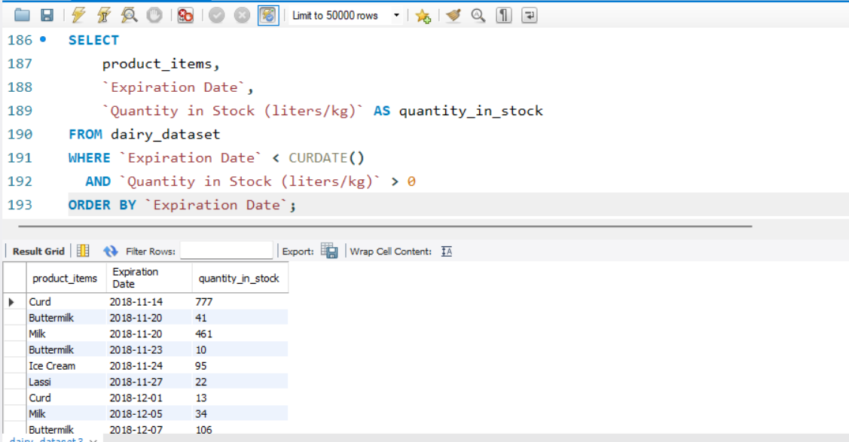
- Average shelf life per brand
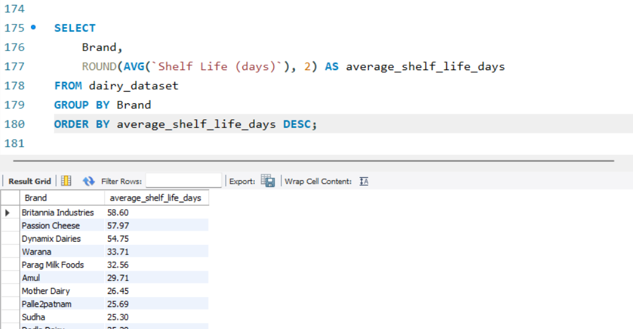
- Most popular product in each customer location
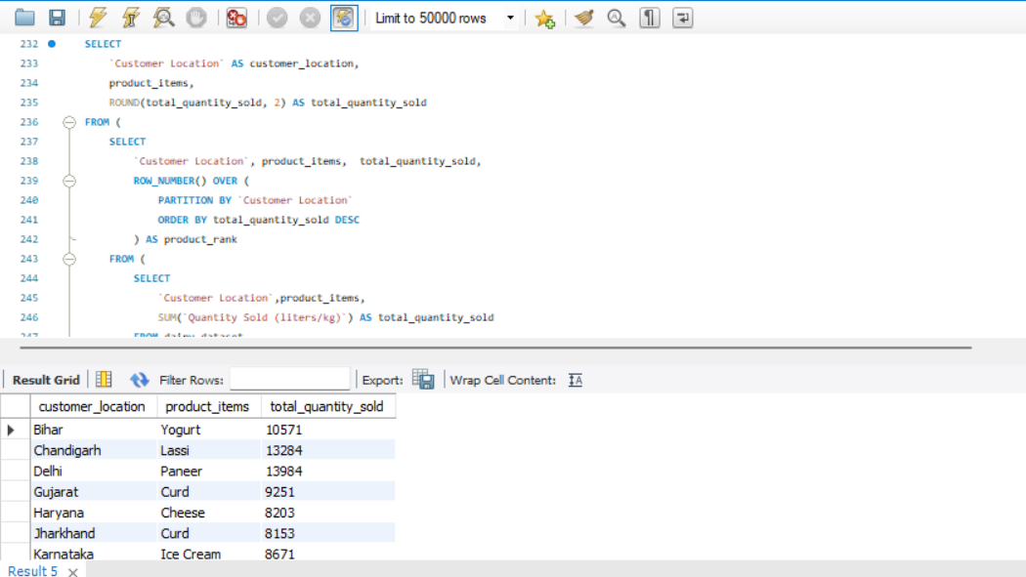

Datasheet Description
The supplied CSV file contains 4,325 records and 23 columns. The transaction date field covers dates from 2019 through 2022. The columns combine sales, product, customer, inventory, and farm information. The file contains no blank values in the reviewed columns.
1. Farm and location information
These fields describe the farm and its location:
- Location: The location associated with the farm.
- Total Land Area (acres): The farm's recorded land area in acres.
- Number of Cows: The recorded number of cows at the farm.
- Farm Size: The dataset's farm-size category.
2. Date and product information
These fields identify when a record was made and which product it concerns:
- Date: The date associated with the sales record.
- Product ID: A numeric identifier for the product.
- Product Name: The product name, such as Milk, Curd, Butter, or Paneer.
- Brand: The brand associated with the product.
3. Quantity, price, and value information
These columns describe product quantities and financial values:
- Quantity (liters/kg): The product quantity recorded in the row.
- Price per Unit: The listed price per unit.
- Total Value: The recorded value associated with the product quantity.
- Quantity Sold (liters/kg): The quantity recorded as sold.
- Price per Unit (sold): The selling price per unit.
- Approx. Total Revenue (INR): The dataset's approximate revenue value in Indian rupees.
For this report, “Approx. Total Revenue (INR)” is used as the revenue measure because that is the field supplied for revenue. Quantities are labeled in liters or kilograms, so the relevant unit depends on the product.
4. Shelf-life and storage information
These fields describe product handling and dates:
- Shelf Life (days): The number of days of shelf life recorded for the product.
- Storage Condition: The stated storage category, such as refrigerated, frozen, or tetra pack.
- Production Date: The product's recorded production date.
- Expiration Date: The recorded expiration date.
5. Customer and sales channel information
These fields describe where and how products were sold:
- Customer Location: The location associated with the customer.
- Sales Channel: The channel recorded for the sale, such as Retail, Wholesale, or Online.
6. Inventory information
These columns provide stock and replenishment details:
- Quantity in Stock (liters/kg): The quantity recorded as currently in stock.
- Minimum Stock Threshold (liters/kg): The stated minimum stock level.
- Reorder Quantity (liters/kg): The quantity listed for reorder.
Conclusions
The supplied dataset records approximately ₹5.87 crore in total approximate revenue across the period from 2019 to 2022. Among the brands represented, Amul has the highest recorded total revenue. Among individual products, Curd has the highest recorded revenue. These results identify the leading brand and product in the supplied records, but they do not by themselves explain why those sales are higher.
By sales channel, Retail contributes the most recorded revenue, followed by Wholesale and Online. By customer location, Delhi has the highest total purchase volume in the dataset. These findings may help focus additional analysis on retail sales and customer demand in Delhi, while still considering performance in the other channels and locations.
The yearly figures show a decline in recorded revenue over the period: approximately ₹1.52 crore in 2019, ₹1.48 crore in 2020, ₹1.46 crore in 2021, and ₹1.41 crore in 2022. This pattern suggests that the decrease should be investigated further. A more detailed review could compare products, brands, channels, and locations year by year to identify where the change occurred.
The inventory fields flag 918 records where the recorded stock quantity is below the minimum stock threshold. This may indicate a need to review replenishment, but the count is of records, not necessarily 918 distinct products. The dataset also contains 2,564 records where the expiration date is earlier than the recorded sales date. Because that result is unusually high, the date fields and row definitions should be validated before treating these records as confirmed expired-product sales.
Overall, the dataset supports a broad review of revenue, product performance, channels, customer locations, and inventory indicators. The results are useful as an initial analysis, but conclusions about profit, stock action, and expired products depend on confirming the relevant cost assumptions and validating how each row and date field should be interpreted.

